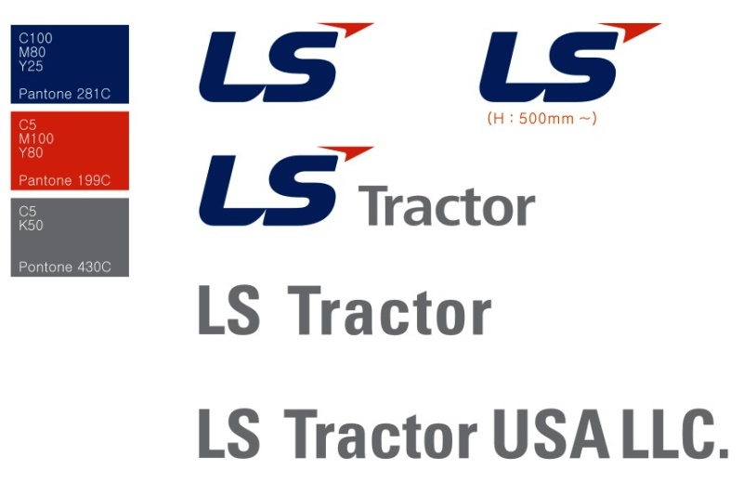

[January 1, 2021]

[Addressee]

[Dealership Name]

[Street Address]

[City, State Zip]

[Dear Mr./Ms. Addressee],

It is with great pleasure that I welcome you to the LS Tractor family! We’re pleased to have you on our team and look forward to working with you. In anticipation of this day the LS support teams have completed your onboarding procedures to ensure that you’ll have a seamless experience during the next few weeks.

Please keep your Business Manager’s contact information handy as he is your key liaison to LS Tractor. He will answer questions, set up product and service training, provide industry retail data for your territory, assist with selecting tractors and implements for your first order and provide a broad variety of other support.

By now you’ve received an email that included your dealer number and Dealer Portal instructions. The Dealer Portal contains virtually all the information you’ll need to keep your dealership running smoothly, including product training videos, marketing support, co-op information, pricing and programs, and lots of other useful information. I encourage you to spend time learning your way around and exploring all its features.

Within the next few days, I’ll call you to personally introduce myself and get to know you and your dealership. And remember, you and your team have an open invitation to visit our Battleboro, NC headquarters any time to meet our teams.

We appreciate your confidence and will work hard to keep earning your trust every day. Thanks again for joining our LS Tractor family!

Best Regards,

M

Mark Oehmke

Vice President, Sales and Dealer Development

Mobile: 228-364-2817